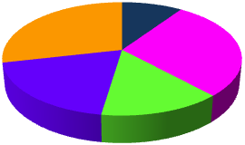

**Mined Systems Inc.**

**Metrics Intelligence ©**

# 

**SOW 5, v2 Design Document, Release 12.11**

**October 17, 2012**

Table of Contents

1 Adjustment of Main Navigation Buttons 5

2 REPORTS: Re-creation of “Original” Reports 6

2.1 Franchisee Reports 7

2.1.1 New Appointments by Source (By Month) 7

2.1.2 New Clients by Product Type (By Month) 7

2.1.3 New Client Quantity & Average Contract Price (By Month) 7

2.1.4 Class Headcount by Course & Industry (By Month) 7

2.1.5 Average Length of Time for Active Clients (By Industry) 8

2.1.6 Actual Dollars Booked and Comparison to Goal (By Month) 8

2.1.7 Data Access by User-Role (for All “Franchisee” Reports) 8

2.2 Client Reports 9

2.2.1 Cost of Sale 10

2.2.2 Sales Cycle Time 11

2.2.3 Sales Total by Month 12

2.2.4 Sandler Sales Rep Retention (not built for SOW 5) 14

2.2.5 Pipeline Post Training (not built for SOW 5) 14

2.2.6 Client Sales Rep Retention (not built for SOW 5) 14

2.2.7 Client Return on Investment (not built for SOW 5) 14

2.3 Product Reports 15

2.3.1 Product Margin Contribution 15

2.3.2 Products Sold as a 1st Sale 15

2.3.3 Products Sold by Company 15

2.3.4 Products Sold by Rep 15

2.4 Ad Hoc Reports 16

2.4.1 Closed Sales Analysis (By Month) 16

2.4.2 Pipeline Opportunity Analysis (By Month) 22

3 Benchmark Reports 27

3.1 Rep to Franchise 27

3.2 Franchisee to Region 27

3.3 Region to Country 27

3.4 Country to “All” 27

4 “My Account” Update – Customize Dashboard Option 28

5 Functionality for “Client” User 29

5.1 Client Login Functionality 29

5.2 Client Main Navigation 29

5.2.1 Data Access by User-Role 29

5.3 Client Reports 30

5.4 Client Benchmark Reports 30

5.5 Client CRM Functionality 30

5.6 Client “My Account” Functionality 30

6 Sending Meeting Invite from SMS 31

**Table of Figures**

Figure 1‑1: Updated Main Navigation 5

Figure 2‑1: Updated “Reports” Selection 6

Figure 2‑2: Franchisee Report Selection 7

Figure 2‑3: Client Report Selection 9

Figure 2‑4: Cost of Sale (By Product) 10

Figure 2‑5: Sales Cycle Time 12

Figure 2‑6: Sales Total (By Month) 13

Figure 2‑7: Product Report Selection 15

Figure 2‑8: Ad Hoc Report Selection 16

Figure 2‑9: Sales Value by Product (By Month) 18

Figure 2‑10: Sales Quantity by Product (By Month) 19

Figure 2‑11: Sales Value Percentage by Product (Jul) 20

Figure 2‑12: Sales Quantity Percentage by Product (Jul) 21

Figure 2‑13: Pipeline Value by Product (By Month) 23

Figure 2‑14: Pipeline Quantity by Product (By Month) 24

Figure 2‑15: Pipeline Value Percentage by Product (Oct) 25

Figure 2‑16: Pipeline Quantity Percentage by Product (Oct) 26

Figure 3‑1: Benchmark Report Selection 27

Figure 5‑1: Client Dashboard 30

**NOTE: Updates in Version 2 are in BLUE text.**

# Adjustment of Main Navigation Buttons

To accommodate the updates for the report improvements, and the addition of “Benchmark” reports, the Main Navigation buttons need to be adjusted. The following figure shows the updated main navigation display. The details for the updated reports and benchmark details are located in the following sections of this document.

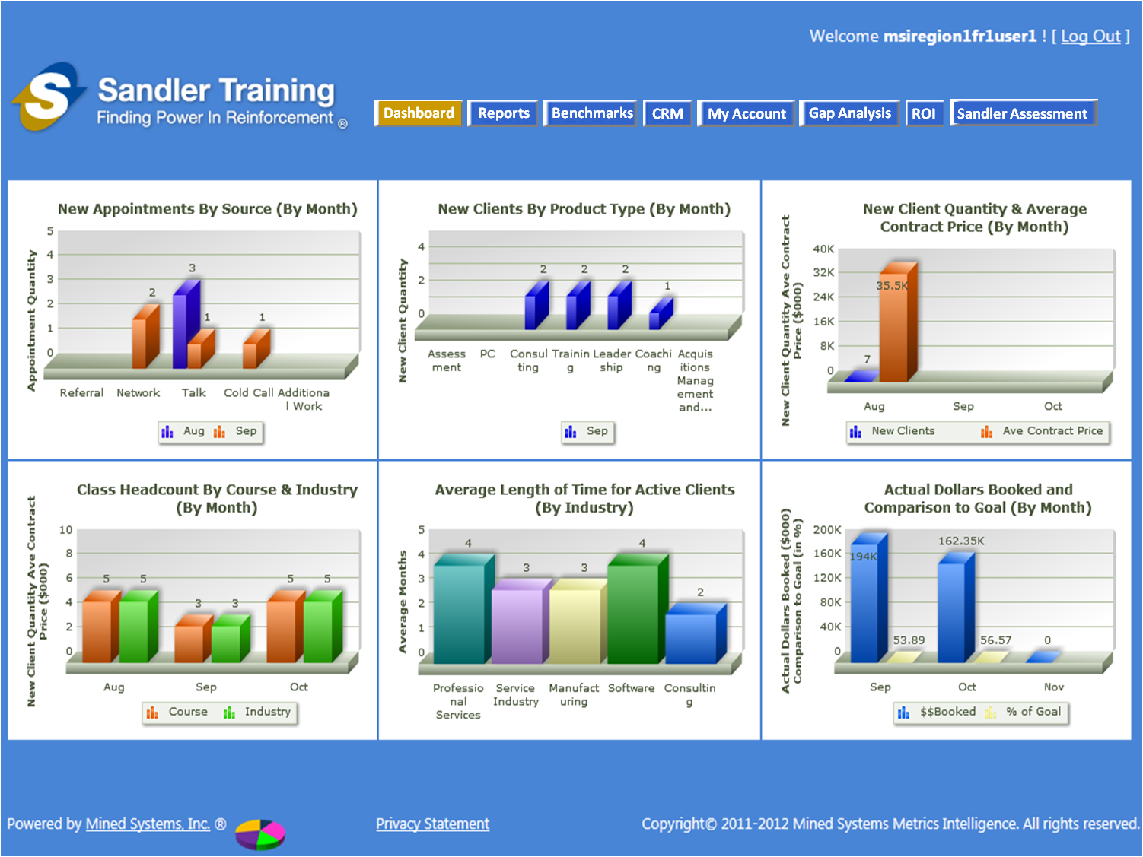

Figure ‑: Updated Main Navigation

# REPORTS: Re-creation of “Original” Reports

The following sections identify the “original” [e.g. Sandler SOW 1] reports that have been requested by Sandler to be “re-inserted” into the application. The following figure shows the updated “Reports” menu button and how the report selection should function as a result of the updated navigation.

When the user “mouses-over” the “Reports” button in the main navigation the 4 different types of reports will be shown in a “drop down” below the “Reports” button. Further, when the user “mouses-over” any of the 4 options, the various reports [for each of those options] will be shown in a “2nd-tier” drop down menu as shown in the respective sub-sections below.

The figure below shows the 1st level “mouse-over” drop down that shows the 4 report types:

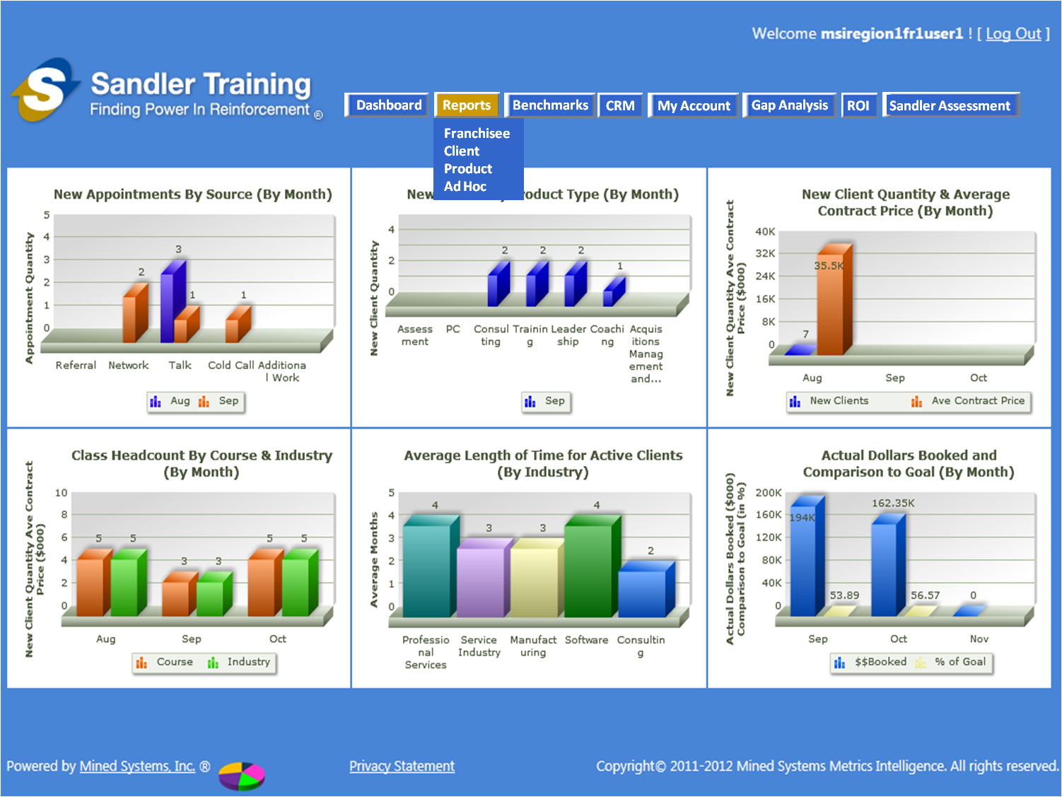

Figure ‑: Updated “Reports” Selection

## Franchisee Reports

The method for selecting the Franchisee reports is as shown in the figure below. As the user “mouses-over” the “Reports” button on the main navigation, the 4 Report Types will appear with the “Franchisee” option highlighted. When the user “mouses-over” the “Franchisee” option, the available “Franchisee Reports” will appear to the right [as shown in the figure below]. The user will then have the option to “mouse-over” any of the available “Franchisee Reports” to click and select the desired report.

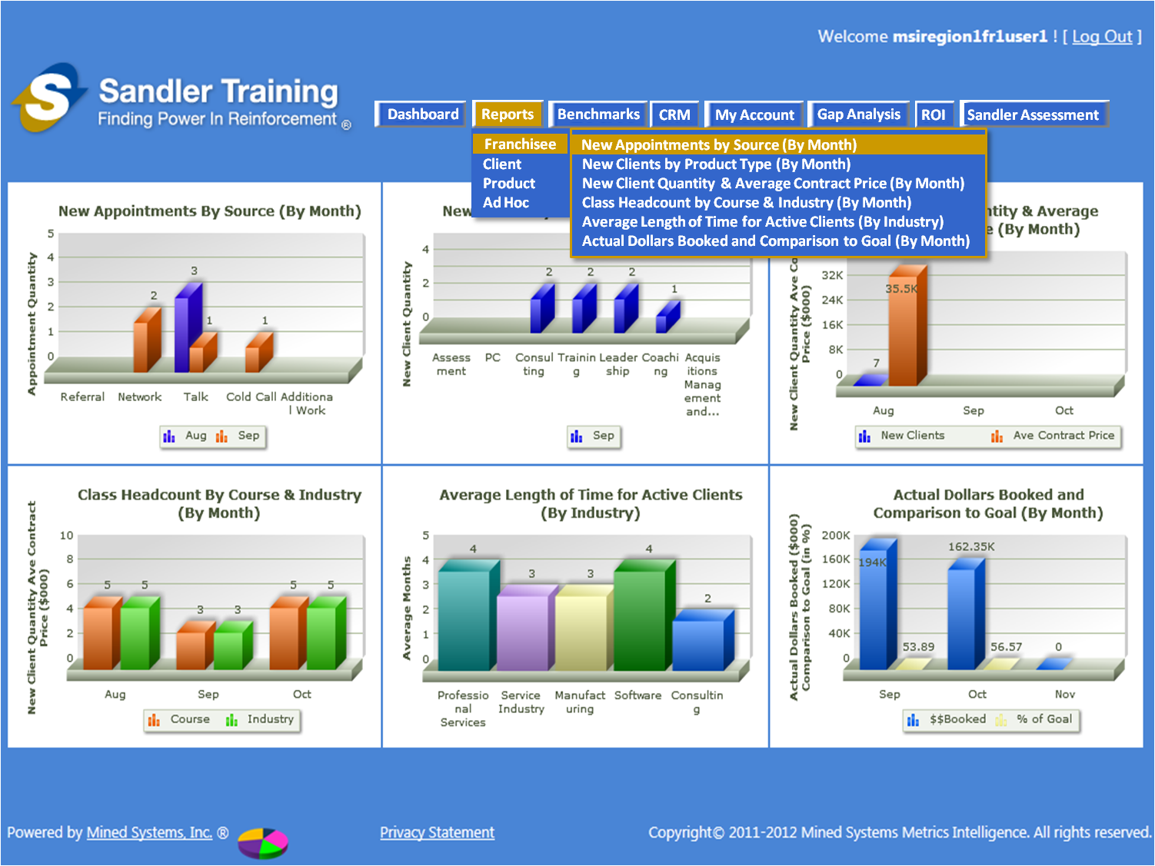

Figure ‑: Franchisee Report Selection

### New Appointments by Source (By Month)

There is no adjustment to the parameters for this report as originally defined in Sandler SOW 2.

### New Clients by Product Type (By Month)

There is no adjustment to the parameters for this report as originally defined in Sandler SOW 2.

### New Client Quantity & Average Contract Price (By Month)

There is no adjustment to the parameters for this report as originally defined in Sandler SOW 2.

### Class Headcount by Course & Industry (By Month)

There is no adjustment to the parameters for this report as originally defined in Sandler SOW 2.

### Average Length of Time for Active Clients (By Industry)

There is no adjustment to the parameters for this report as originally defined in Sandler SOW 2.

### Actual Dollars Booked and Comparison to Goal (By Month)

There is no adjustment to the parameters for this report as originally defined in Sandler SOW 2.

### Data Access by User-Role (for All “Franchisee” Reports)

The following data access by user role is applicable to all 6 of the “Franchisee” reports identified in this section.

* Franchise User Role
  + ALL data in the database for THIS FRANCHISE ONLY that have been created by this Franchise User ONLY will be presented in this screen [for example – Franchise User #1 can see data they have created, but they CANNOT see any data that Franchise User #2 has created]
* Franchise Owner Role
  + ALL data in the database for THIS FRANCHISE ONLY will be presented in this screen
* Coach Role
  + ALL data in the database for ALL FRANCHISES within the Coach’s REGION will be presented in this screen
* Corporate Role
  + ALL data in the database for ALL FRANCHISES will be presented in this screen

## Client Reports

The method for selecting the Client reports is as shown in the figure below. As the user “mouses-over” the “Reports” button on the main navigation, the 4 Report Types will appear with the “Franchisee” option highlighted. When the user “mouses-over” the “Client” option, the available “Client Reports” will appear to the right [as shown in the figure below]. The user will then have the option to “mouse-over” any of the available “Client Reports” to click and select the desired report.

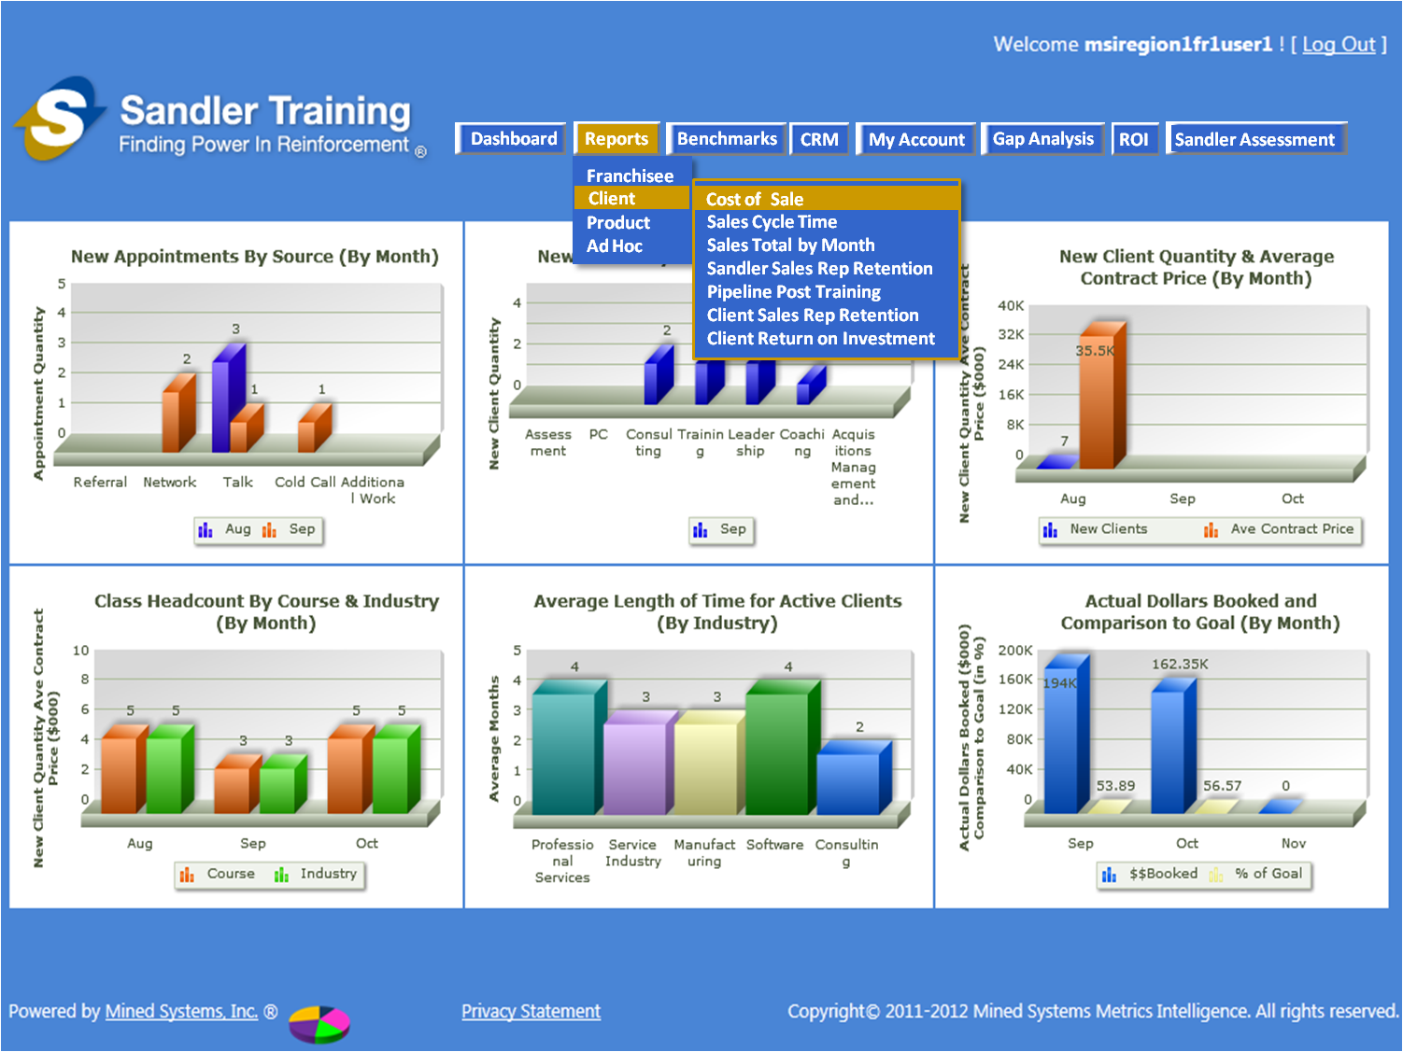

Figure ‑: Client Report Selection

### Cost of Sale

We need to **add a field** called “Product Cost” on the data input screen for an opportunity so that we can produce this report. This new field should be located **DIRECTLY BENEATH** the “Product” field on the data input screen.

We also need to have the “Product Cost” field in the exported excel file as well. This column should be located **TO THE RIGHT** of the “Product” column in the exported excel file.

**NOTE**: This field does **NOT** need to be on the Pipeline Summary screen.

The report will then need to show [by product] the Revenue, Cost and then Profit [where profit = revenue minus cost].

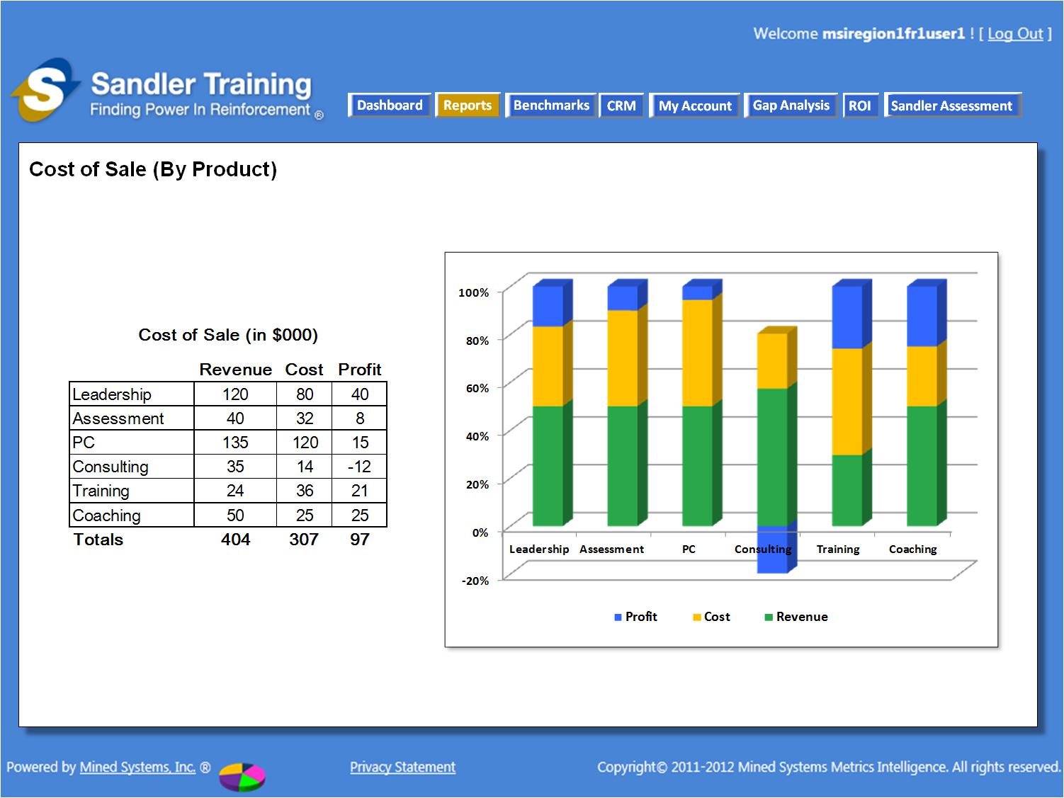

Figure 2‑4: Cost of Sale (By Product)

The details for the report are as follows:

* Product = “Product” field from the Opportunity table
* Revenue = “Opportunity Value” field from the Opportunity table
* Cost = “Product Cost” field (new field) from the Opportunity table
* Profit = Revenue minus Cost

#### Data Access by User-Role

* Franchise User Role
  + ALL Products for ALL Opportunities in the database for THIS FRANCHISE ONLY that have been created by this Franchise User ONLY will be presented in this screen [for example – Franchise User #1 can see data they have created, but they CANNOT see any data that Franchise User #2 has created]
* Franchise Owner Role
  + ALL Products for ALL Opportunities in the database for THIS FRANCHISE ONLY will be presented in this screen
* Coach Role
  + ALL Products for ALL Opportunities in the database for ALL FRANCHISES within the Coach’s REGION will be presented in this screen
* Corporate Role
  + ALL Products for ALL Opportunities in the database for ALL FRANCHISES will be presented in this screen

### Sales Cycle Time

Sales Cycle Time is the calculated time from the time the opportunity was “created” until the “close date” of the opportunity. Therefore, we need to **add a field** called “Created Date” on the data input screen for an opportunity so that we can produce this report. This new field should be located **DIRECTLY ABOVE** the “Close Date” field on the data input screen.

We also need to have the “Created Date” field in the exported excel file as well. This column should be located **TO THE LEFT** of the “Close Date” column in the exported excel file.

**NOTE**: This field does **NOT** need to be on the Pipeline Summary screen.

The report will then need to show the sales cycle time for all of the opportunities within the entire portfolio, based upon the data access rights of the user role.

#### Data Access by User-Role

* Franchise User Role
  + ALL Products for ALL Opportunities in the database for THIS FRANCHISE ONLY that have been created by this Franchise User ONLY will be presented in this screen [for example – Franchise User #1 can see data they have created, but they CANNOT see any data that Franchise User #2 has created]
* Franchise Owner Role
  + ALL Products for ALL Opportunities in the database for THIS FRANCHISE ONLY will be presented in this screen
* Coach Role
  + ALL Products for ALL Opportunities in the database for ALL FRANCHISES within the Coach’s REGION will be presented in this screen
* Corporate Role
  + ALL Products for ALL Opportunities in the database for ALL FRANCHISES will be presented in this screen

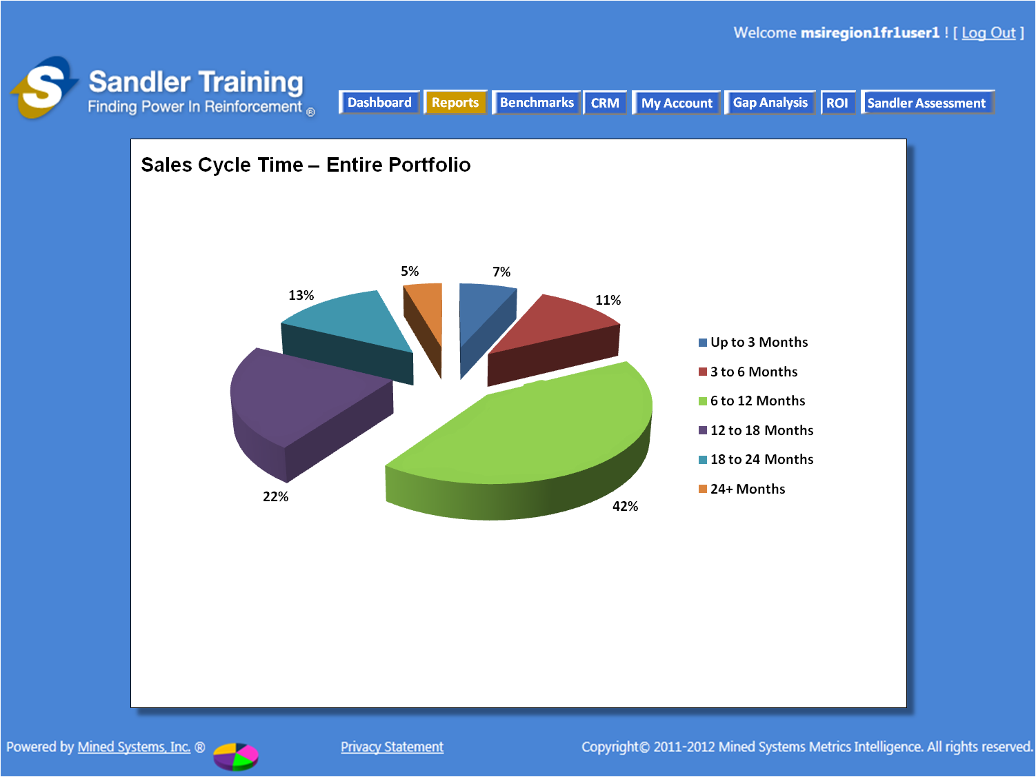

Figure 2‑5: Sales Cycle Time

### Sales Total by Month

“Sales Total by Month” report shows the “by month” total dollar value and total quantity of ALL opportunities with a “close date” of the current year and the two previous years and should always show the “January thru December” months for those 3 years.

The ONLY opportunities to be shown in the **two previous years** are where the “Opportunity Status” also equals “Closed Won” which indicates that the opportunity was actually “Won” and the sale was actually made.

The values for the **CURRENT YEAR** should be a total of ALL opportunities for the current year where the “Opportunity Status” does NOT equal “Closed Lost”. By doing this, we will include all “Closed Won” opportunities AND any opportunities that are in the “Pipeline” with a “close date” of the current year.

The bar graph shows the QUANTITY of the sales for the current year and **two previous years**, following the same logic for what opportunities to include in the numbers as specified in the preceding paragraphs in this section.

#### Data Access by User-Role

* Franchise User Role
  + ALL Opportunities in the database for THIS FRANCHISE ONLY that have been created by this Franchise User ONLY will be presented in this screen [for example – Franchise User #1 can see data they have created, but they CANNOT see any data that Franchise User #2 has created]
* Franchise Owner Role
  + ALL Opportunities in the database for THIS FRANCHISE ONLY will be presented in this screen
* Coach Role
  + ALL Opportunities in the database for ALL FRANCHISES within the Coach’s REGION will be presented in this screen
* Corporate Role
  + ALL Opportunities in the database for ALL FRANCHISES will be presented in this screen

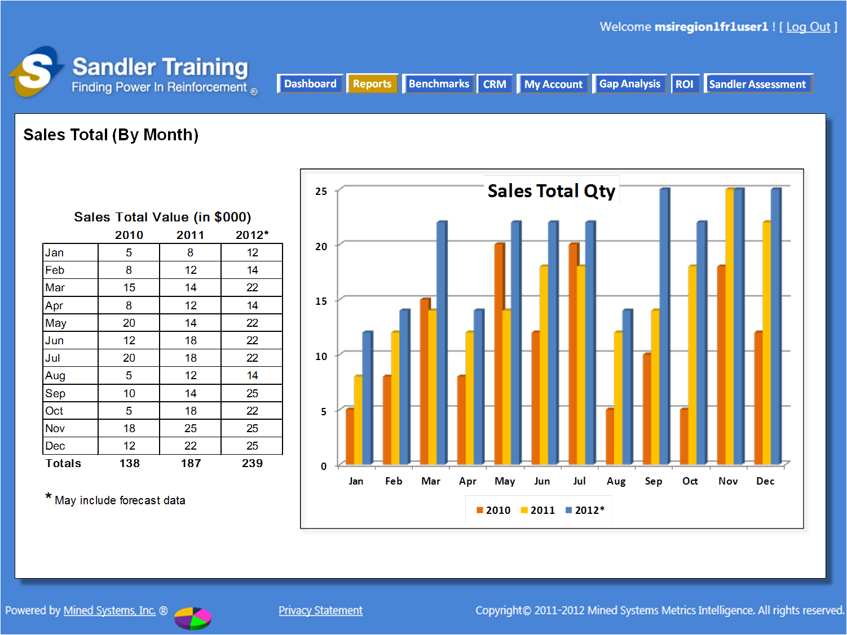

Figure ‑: Sales Total (By Month)

### Sandler Sales Rep Retention (not built for SOW 5)

Note: This report will ONLY have the name in the drop down list – but there will be no report built as part of SOW 5.

### Pipeline Post Training (not built for SOW 5)

Note: This report will ONLY have the name in the drop down list – but there will be no report built as part of SOW 5.

### Client Sales Rep Retention (not built for SOW 5)

Note: This report will ONLY have the name in the drop down list – but there will be no report built as part of SOW 5.

### Client Return on Investment (not built for SOW 5)

Note: This report will ONLY have the name in the drop down list – but there will be no report built as part of SOW 5.

## Product Reports

The method for selecting the Product reports is as shown in the figure below. As the user “mouses-over” the “Reports” button on the main navigation, the 4 Report Types will appear with the “Franchisee” option highlighted. When the user “mouses-over” the “Product” option, the available “Product Reports” will appear to the right [as shown in the figure below]. The user will then have the option to “mouse-over” any of the available “Product Reports” to click and select the desired report.

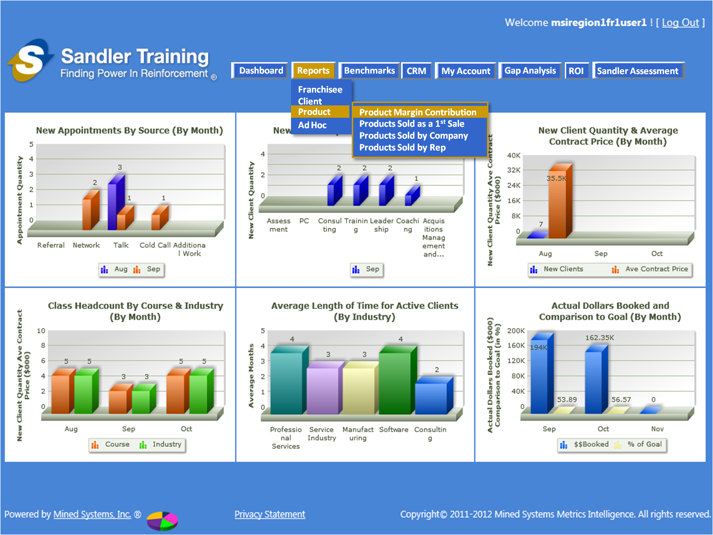

Figure ‑: Product Report Selection

### Product Margin Contribution

### Products Sold as a 1st Sale

### Products Sold by Company

### Products Sold by Rep

## Ad Hoc Reports

The method for selecting the Ad Hoc reports is as shown in the figure below. As the user “mouses-over” the “Reports” button on the main navigation, the 4 Report Types will appear with the “Franchisee” option highlighted. When the user “mouses-over” the “Ad Hoc” option, the available “Ad Hoc Reports” will appear to the right [as shown in the figure below]. The user will then have the option to “mouse-over” any of the available “Ad Hoc Reports” to click and select the desired report.

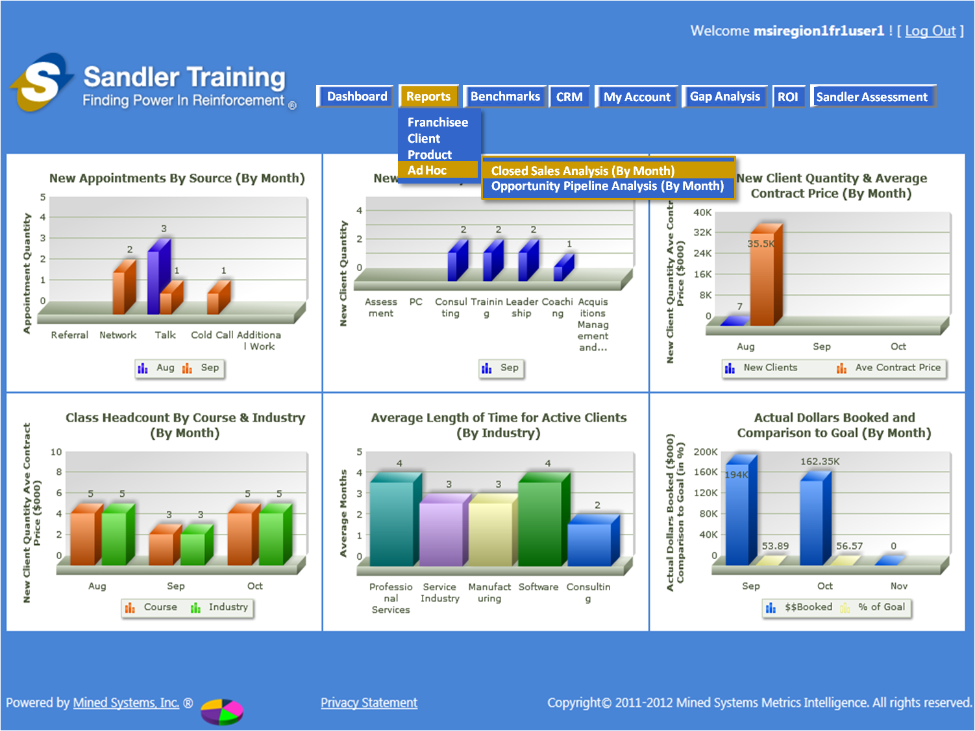

Figure ‑: Ad Hoc Report Selection

### Closed Sales Analysis (By Month)

Based upon the access roles identified below, this report provides the user with the ability to see what sales have been completed by: Products Sold; Opportunity Source; Opportunity Type; or Sales Rep. This report allows the user to assess how sales by product, source, type, or sales rep compare to the overall sales for an individual company or multiple companies. In addition, this analysis can be presented by sales VALUE **OR** sales QUANTITY, **but not BOTH.**

When the user selects this report, they will be presented with a screen to perform the following steps in making their selections and running the report:

**Step 1 – Select “Closed Sales Analysis” Type**

* When presented with the option of what to conduct the “Closed Sales Analysis” on, the user will need to select ONE AND ONLY ONE of the following:
* Products Sold
* Opportunity Source
* Opportunity Type
* Sales Rep

**Step 2 – Select Company(ies)**

* When presented with the “Company” selection, the user will be able to make a selection as follows:
* Select ONLY New Companies (e.g. this is where the “New Company” flag is “Yes”)
* Select ONLY Non-New Companies (e.g. the “New Company” flag is “No”)
* Select All Companies
* Select multiple companies (from the drop down list)
* Select 1 company (from the drop down list)

**Step 3 – Select Quantity / Value Choice**

* When presented with the Sales VALUE / Sales QUANTITY selection, the user will be able to make a selection as follows:
* Sales VALUE (1 **bar** chart will appear)
* Sales QUANTITY (1 **bar** chart will appear)

**Step 4 – View the Report**

* When the selections have been made in Steps 1 thru 3, the report will be presented in a BAR CHART as follows:
* The bars will be grouped with the 3 months together for each of the possible “Closed Sales Analysis” types
* EXAMPLE: If the user chose to see the “Value” of a report that happened to have close dates of July, August, and September for “Products Sold”, then the groupings would be Jul Aug Sep for Assessment, PC, Consulting, etc. as shown in the figure below:

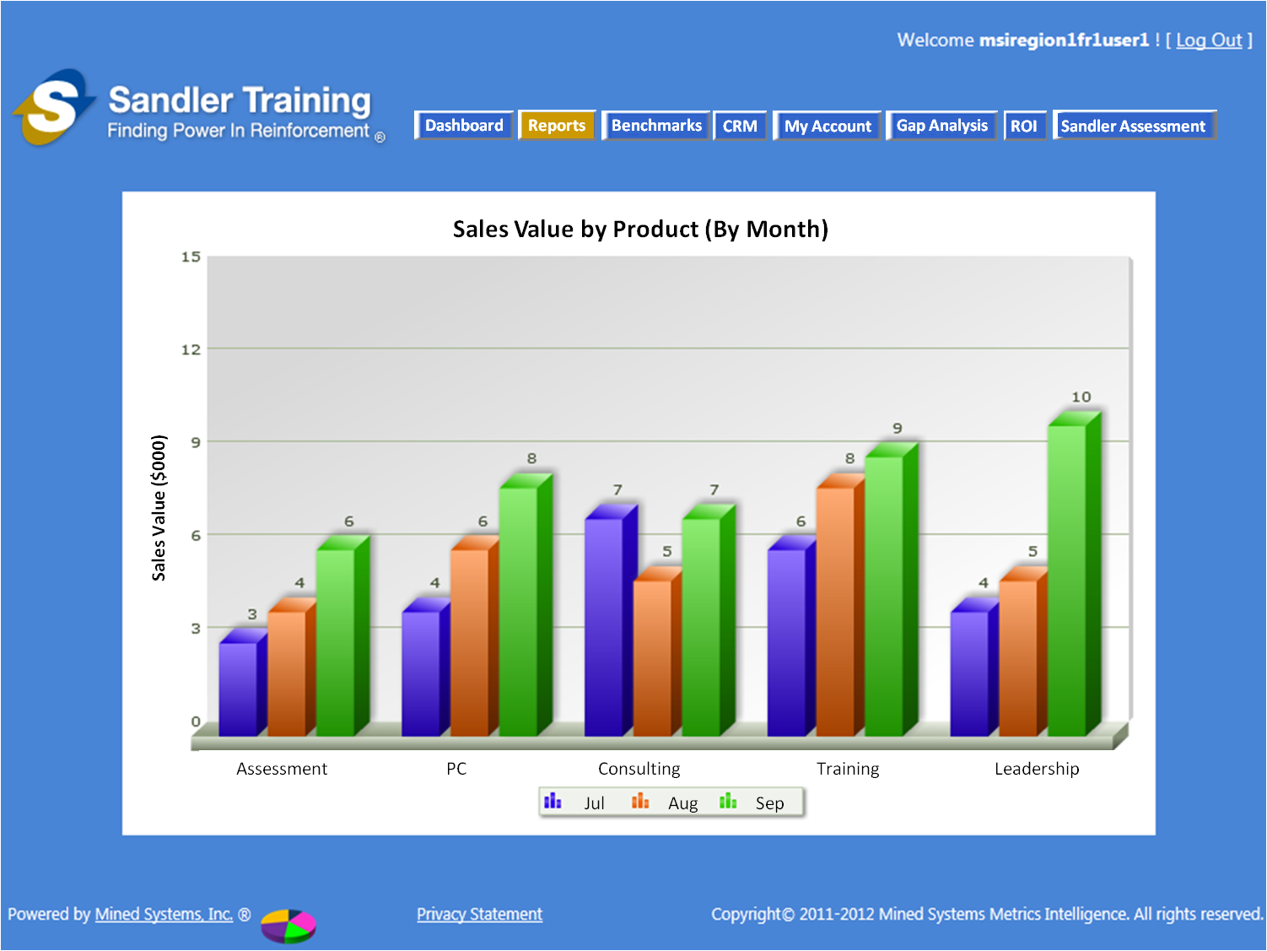

Figure ‑: Sales Value by Product (By Month)

* EXAMPLE: If the user chose to see the “Quantity” of the report identified in the example above, the report would be as shown in the figure below:

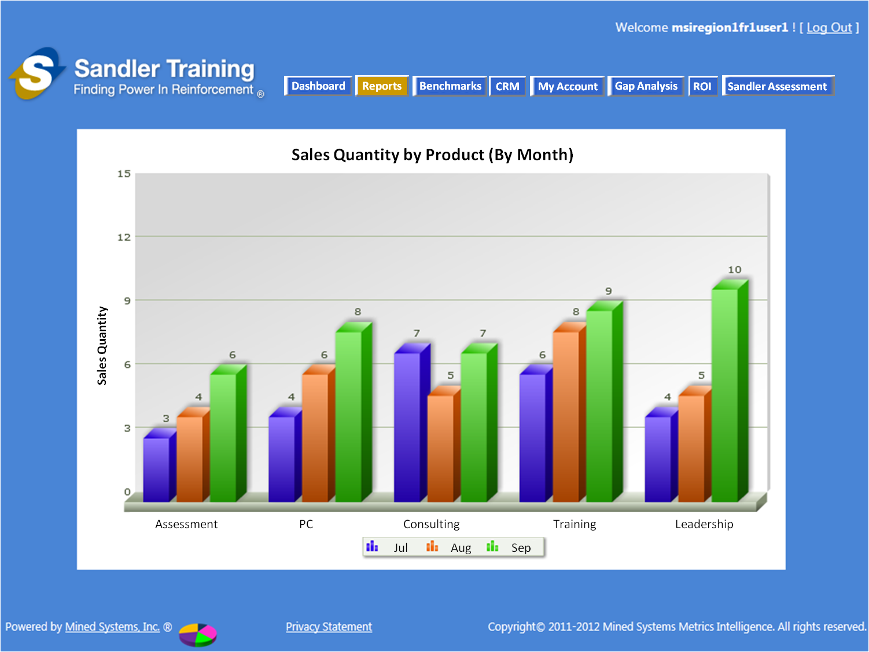

Figure ‑: Sales Quantity by Product (By Month)

* Depending upon the choice selected in Step 3 by the user, the data will be presented for all of the opportunities closed within the PAST 3 MONTHS for the company(ies) selected (in Step 2) **AND** where the “OPPORTUNITY STATUS” value is equal to “CLOSED WON”
* The “Value” amount to use for the calculations should be from the “ACTUAL VALUE” field

**Step 5 – Print the Report**

* Once presented with the report, the user should have the ability to print the bar chart

**Step 6 – Drill Down into the Details**

* Once presented with the report, the user should have the ability to click on any one of the months for any one of the “Closed Sales Analysis” items (from Step 1)
* By doing this, the user will be presented with a Pie Chart for that particular month, for that particular selection [e.g. one of the Products Sold, or one of the Opportunity Source types, etc]
* EXAMPLE: Continuing the thought process of the example above, if the user selected the month of July, the report would be as shown in the figure below:

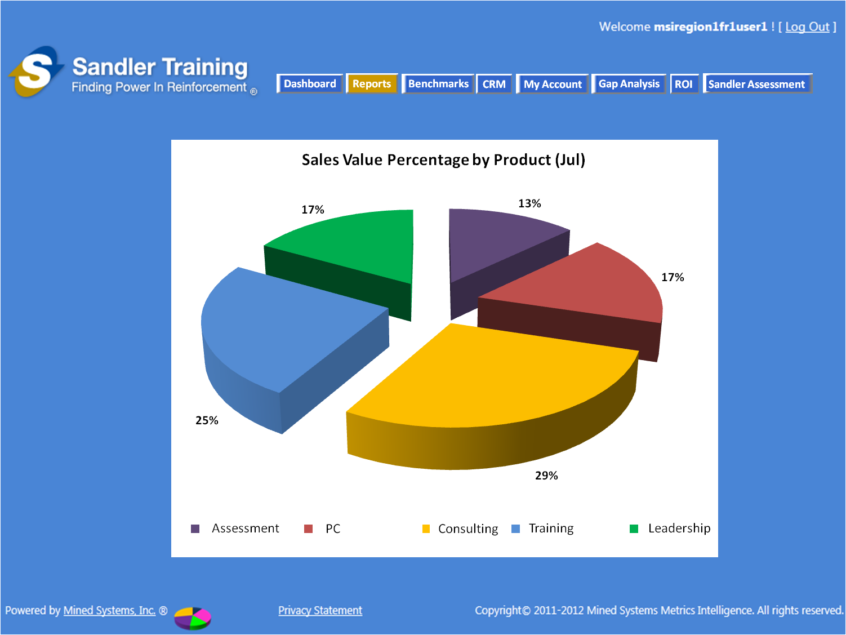

Figure ‑: Sales Value Percentage by Product (Jul)

* EXAMLE : Continuing the thought of the example above, if the user selected “Quantity” instead of “Value”, then the report would be as shown in the figure below:

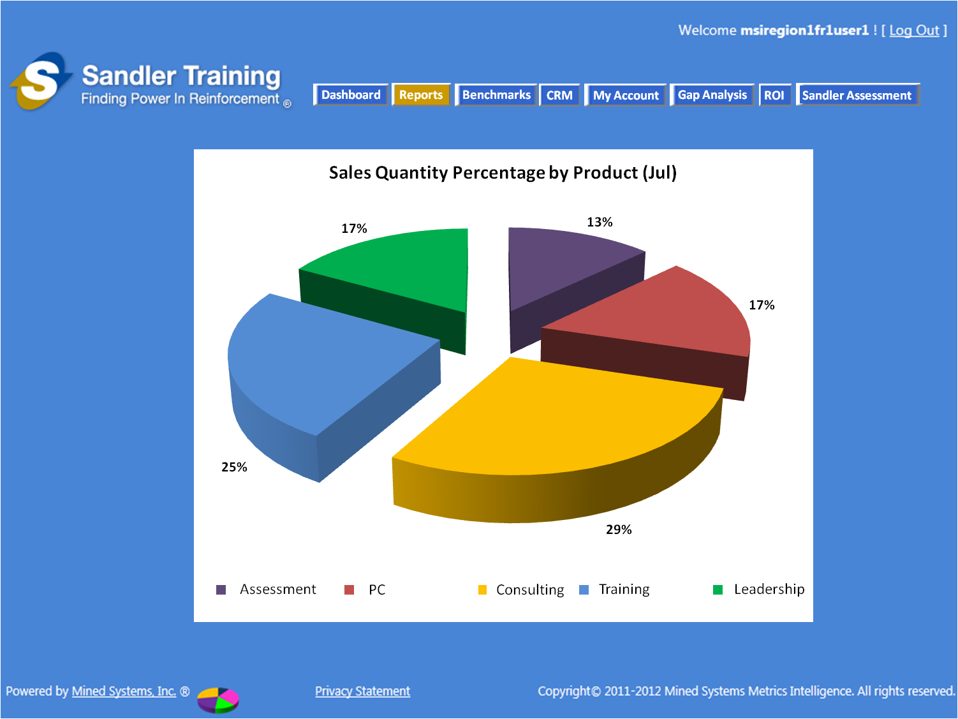

Figure ‑: Sales Quantity Percentage by Product (Jul)

**USER ACCESS**

* Franchise User
* In Step 1, will ONLY be able to select Product Sold, Opportunity Source, or Opportunity Type for ALL opportunities within their franchise ONLY (they will NOT be able to select “Sales Rep” to run this analysis)
* In Step 2, will ONLY be able to select Companies within their franchise
* Franchise Owner
* In Step 1, will be able to make ALL selections for ALL opportunities within their franchise ONLY
* Coach
* In Step 1, will be able to make ALL selections for ALL opportunities within ALL franchises within their Region ONLY
* In Step 2, will be able to make ALL selections for ALL companies within ALL franchises within their Region ONLY
* Franchise Owner
* In Step 1, will be able to make ALL selections for ALL opportunities within ALL franchises
* In Step 2, will be able to make ALL selections for ALL companies within ALL franchises

### Pipeline Opportunity Analysis (By Month)

Based upon the access roles identified below, this report provides the user with the ability to see what sales are in the opportunity pipeline and are scheduled to close within the NEXT 3 MONTHS by: Products Sold; Opportunity Source; Opportunity Type; or Sales Rep. This report allows the user to assess how anticipated sales by product, source, type, or sales rep compare to the overall anticipated sales for an individual company or multiple companies. In addition, this analysis can be presented by sales VALUE **OR** sales QUANTITY, **but not BOTH.**

When the user selects this report, they will be presented with a screen to perform the following steps in making their selections and running the report:

**Step 1 – Select “Pipeline Opportunity Analysis” Type**

* When presented with the option of what to conduct the “Pipeline Opportunity Analysis” on, the user will need to select ONE AND ONLY ONE of the following:
* Product Sold
* Opportunity Source
* Opportunity Type
* Sales Rep

**Step 2 – Select Company(ies)**

* When presented with the “Company” selection, the user will be able to make a selection as follows:
* Select ONLY New Companies (e.g. this is where the “New Company” flag is “Yes”)
* Select ONLY Non-New Companies (e.g. the “New Company” flag is “No”)
* Select All Companies
* Select multiple companies (from the drop down list)
* Select 1 company (from the drop down list)

**Step 3 – Select Quantity / Value Choice**

* When presented with the Sales VALUE / Sales QUANTITY selection, the user will be able to make a selection as follows:
* Sales VALUE (1 **bar** chart will appear)
* Sales QUANTITY (1 **bar** chart will appear)

**Step 4**

* When the selections have been made in Steps 1 thru 3, the report will be presented in a BAR CHART as follows:
* The bars will be grouped with the 3 months together for each of the possible “Pipeline Opportunity Analysis” types
* EXAMPLE: if the user chose to see the “Value” of a report that happened to have close dates planned for October, November, and December for “Products Sold”, then the groupings would be Oct Nov Dec for Assessment, PC, Consulting, etc. as shown in the figure below:

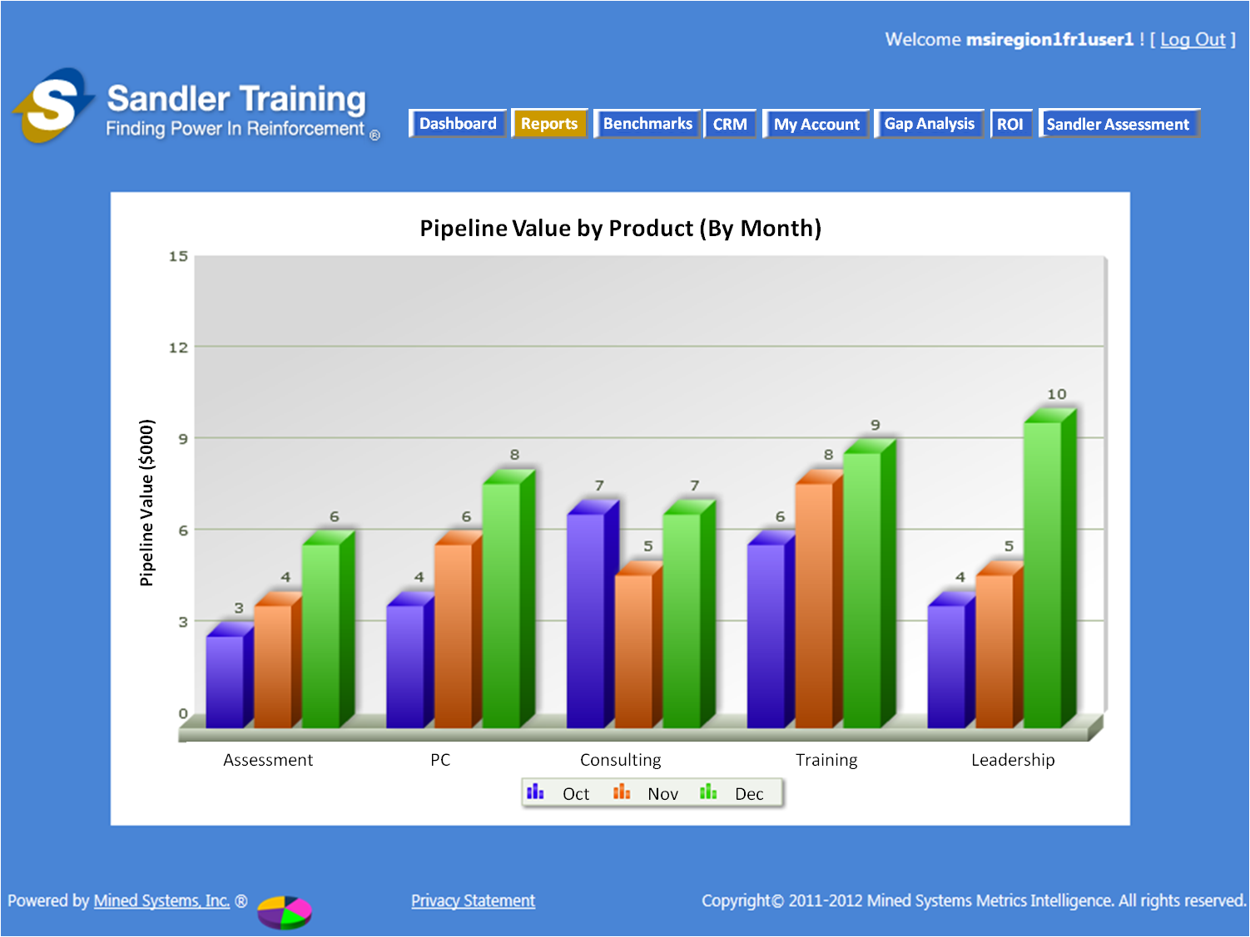

Figure ‑: Pipeline Value by Product (By Month)

* EXAMPLE: If the user chose to see the “Quantity” of the report identified in the example above, the report would be as shown in the figure below:

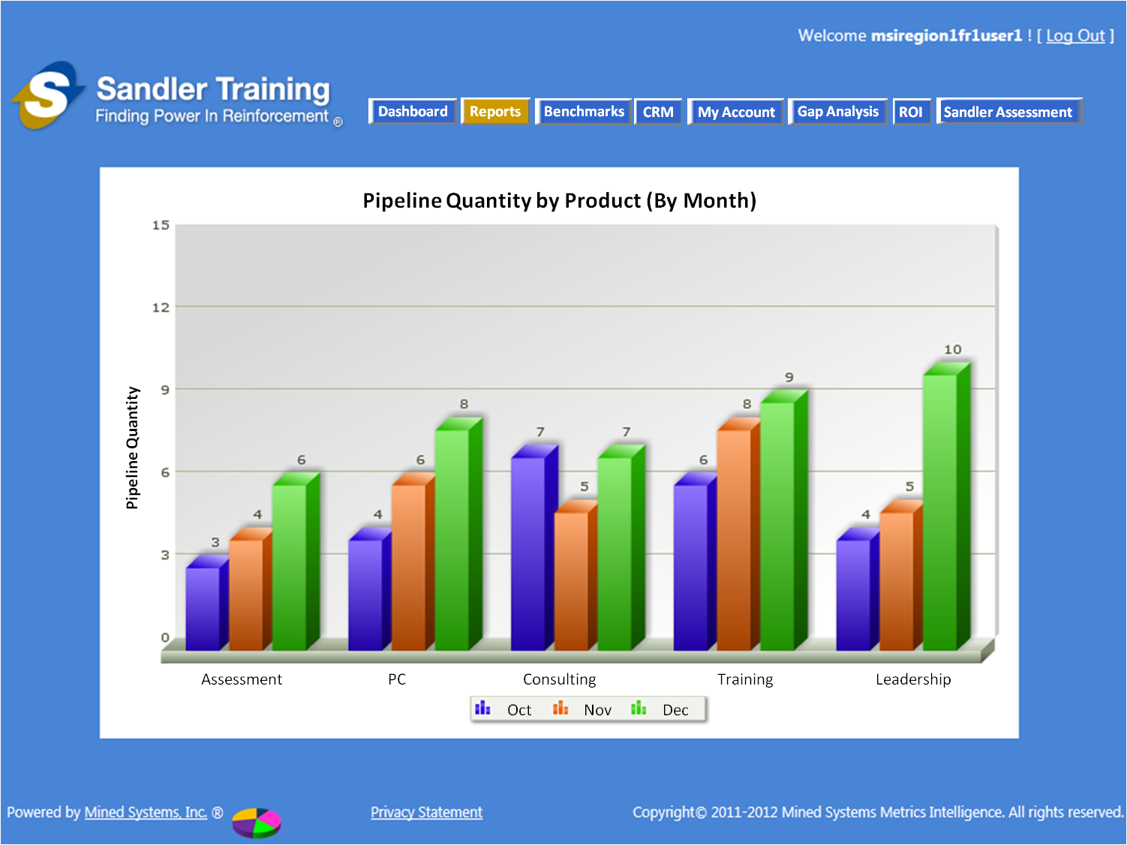

Figure ‑: Pipeline Quantity by Product (By Month)

* Depending upon the choice selected in Step 3 by the user, the data for all of the opportunities with a CLOSE DATE within the CURRENT MONTH and the NEXT 2 MONTHS for the company(ies) selected (in Step 2)
* The “Value” amount to use for the calculations should be from the “WEIGHTED VALUE” field

**Step 5**

* Once presented with the report, the user should have the ability to print the pie chart(s)

**USER ACCESS**

* Franchise User
* In Step 1, will ONLY be able to select Product Sold, Opportunity Source, or Opportunity Type for ALL opportunities within their franchise ONLY (they will NOT be able to select “Sales Rep” to run this analysis)
* In Step 2, will ONLY be able to select Companies within their franchise
* Franchise Owner
* In Step 1, will be able to make ALL selections for ALL opportunities within their franchise ONLY
* Coach
* In Step 1, will be able to make ALL selections for ALL opportunities within ALL franchises within their Region ONLY
* In Step 2, will be able to make ALL selections for ALL companies within ALL franchises within their Region ONLY
* Franchise Owner
* In Step 1, will be able to make ALL selections for ALL opportunities within ALL franchises
* In Step 2, will be able to make ALL selections for ALL companies within ALL franchises

**Step 6 – Drill Down into the Details**

* Once presented with the report, the user should have the ability to click on any one of the months for any one of the “Pipeline Opportunity Analysis” items (from Step 1)
* By doing this, the user will be presented with a Pie Chart for that particular month, for that particular selection [e.g. one of the Products Sold, or one of the Opportunity Source types, etc]
* EXAMPLE: Continuing the thought process of the example above, if the user selected the month of October, the PIE CHART would be as shown in the figure below:

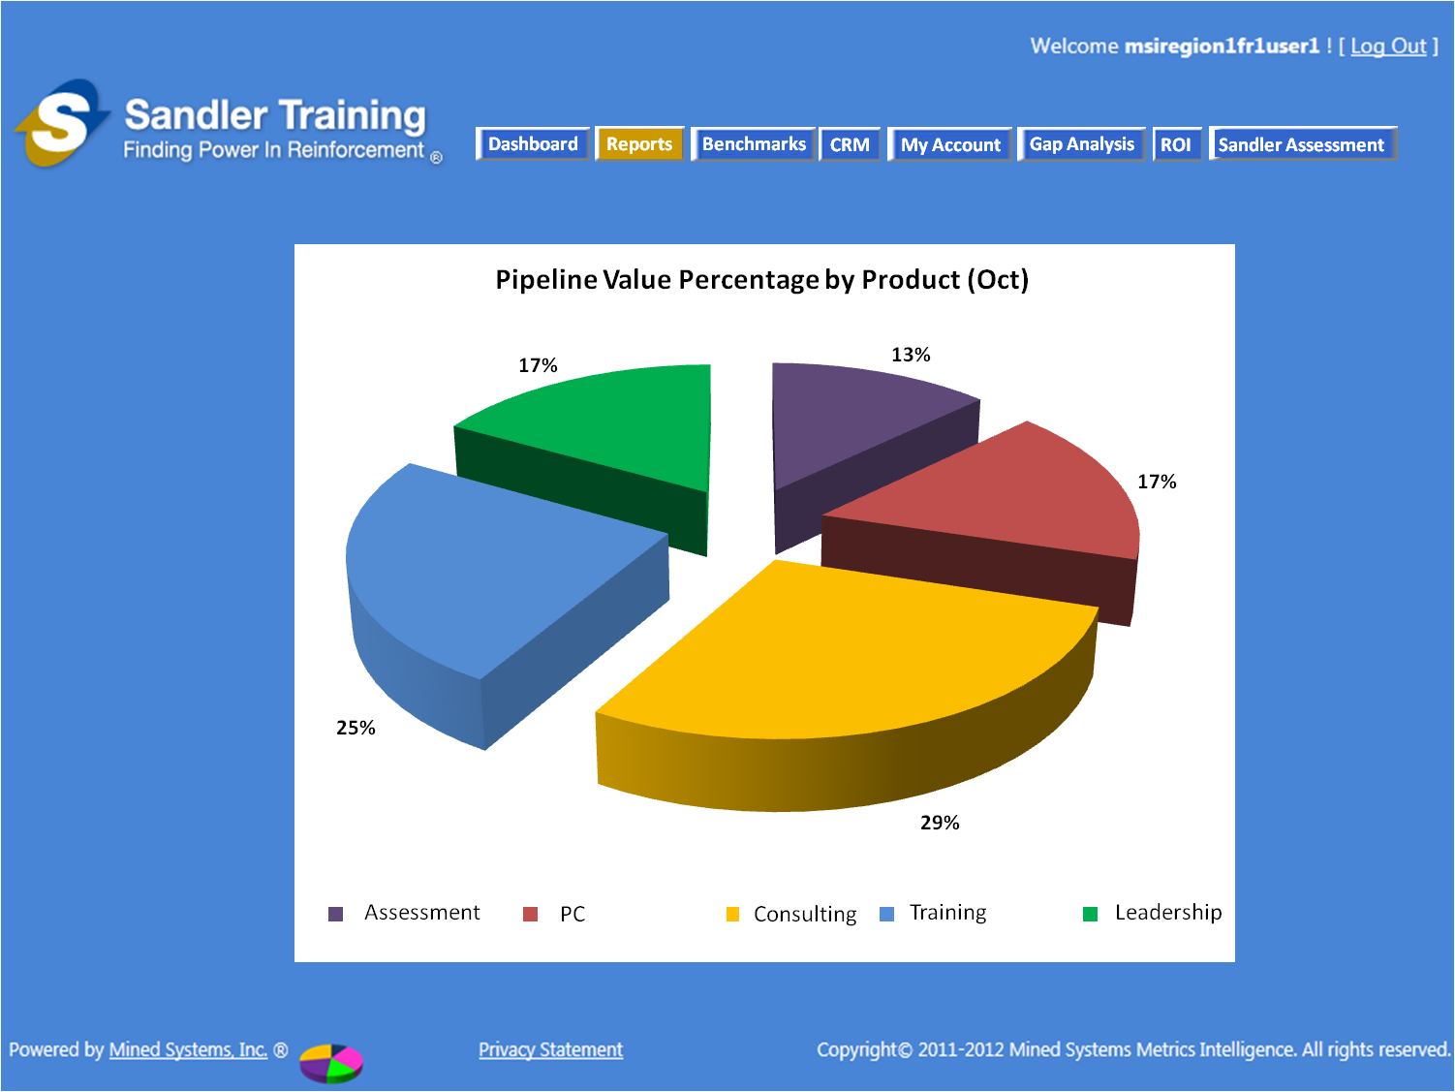

Figure ‑: Pipeline Value Percentage by Product (Oct)

* EXAMLE: Continuing the thought of the example above, if the user selected “Quantity” instead of “Value”, then the PIE CHART would be as shown in the figure below:

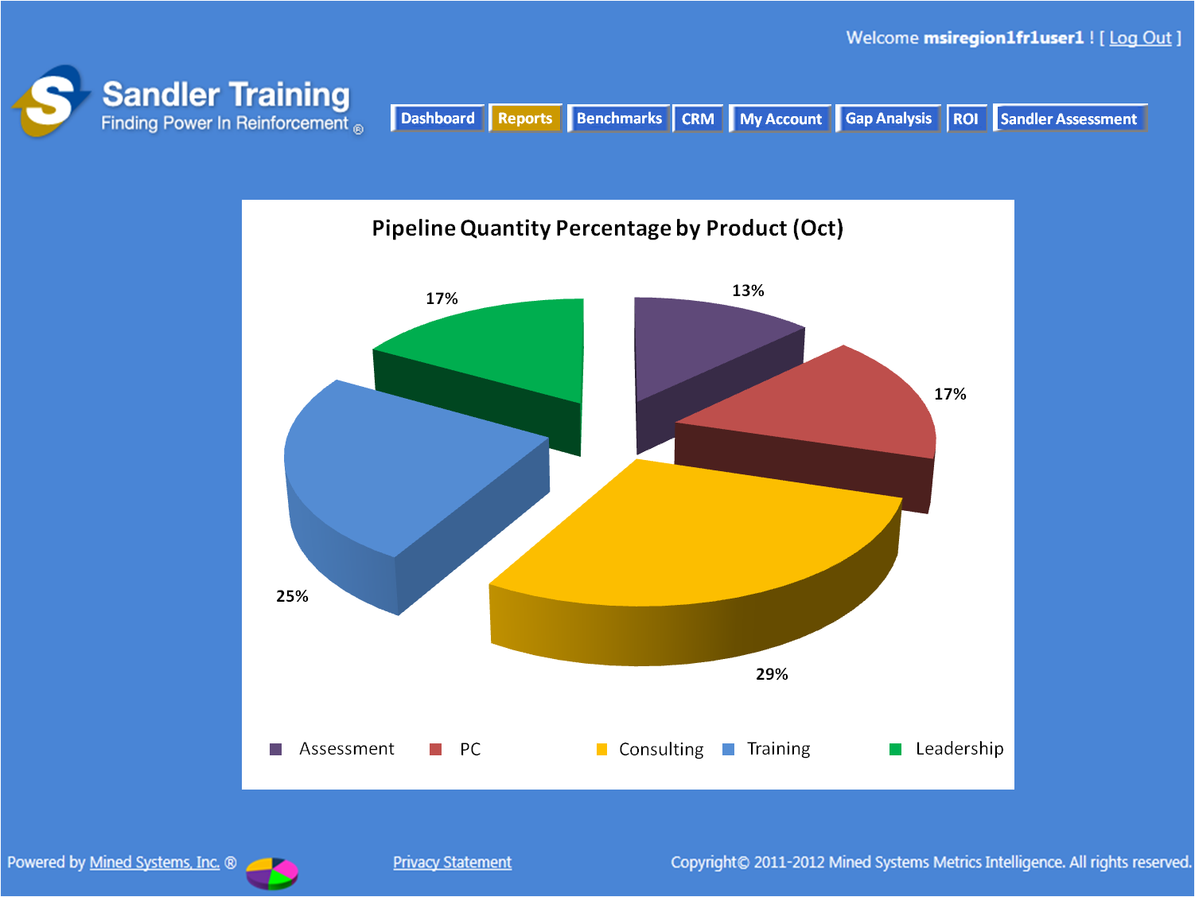

Figure ‑: Pipeline Quantity Percentage by Product (Oct)

# Benchmark Reports

The method for selecting the Benchmark reports is as shown in the figure below. As the user “mouses-over” the “Benchmarks” button on the main navigation, the Benchmark Report Types will appear with the “Rep to Franchise” option highlighted [as shown in the figure below]. The user will then have the option to “mouse-over” any of the available “Benchmark Reports” to click and select the desired report.

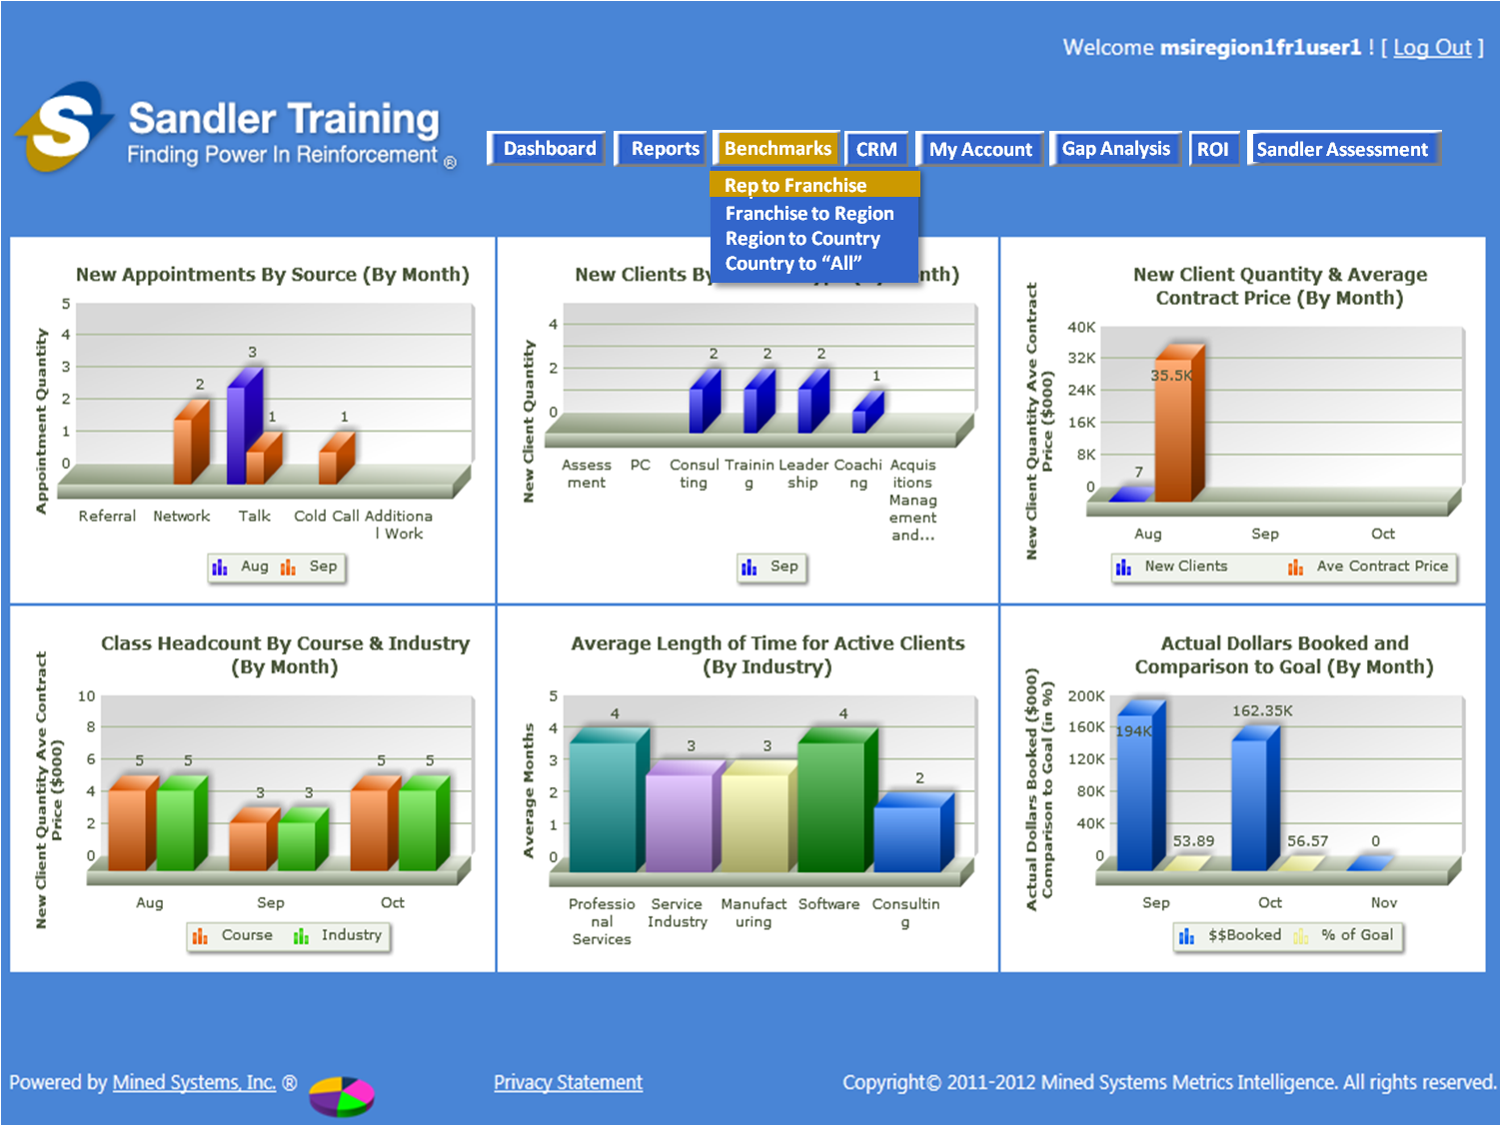

Figure ‑: Benchmark Report Selection

## Rep to Franchise

## Franchisee to Region

## Region to Country

## Country to “All”

# “My Account” Update – Customize Dashboard Option

Because there will now be more than the “basic” 6 reports to run for any of the users, we need to have the capability for the user to select which 6 reports they want to have on their “dashboard”. Therefore, the “Customize Dashboard” option needs to be available under the “My Accounts” main navigation menu.

When the user selects “My Accounts/Customize Dashboard”, they should be presented with the following list of reports [with their existing 6 reports “checked”] along with the ability to “check” or “uncheck” any of the reports in the following list. By selecting “Submit” [or “save”] at the bottom of the selection screen, the user’s dashboard [and ONLY this user’s dashboard] will be updated with the selected 6 reports - - no other user’s GUI presentation will be changed since this is a “user-specific” dashboard update.

Finally – the report “types” [e.g. those in **bold** in the list below] should not be selectable – the user should ONLY be able to select the actual reports noted in the “bullets” below.

**Franchisee Reports**

* New Appointments by Source (By Month)
* New Client by Product Type (By Month)
* New Client Quantity & Average Contract Price (By Month)
* Class Headcount by Course & Industry (By Month)
* Average Length of Time for Active Clients (By Industry)
* Actual Dollars Booked and Comparison to Goal (By Month)

**Client Reports**

* Cost of Sale
* Sales Cycle Time
* Sales Total by Month
* Sandler Sales Rep Retention
* Pipeline Post Training
* Client Sales Rep Retention
* Client Return on Investment

**Product Reports**

* Product Margin Contribution
* Products Sold as a 1st Sale
* Products Sold by Company
* Products Sold by Rep

# Functionality for “Client” User

“Client” will be another “role” for the type of user of the Sandler Metrics System (SMS). This “user” will be classified as a client [e.g. a customer] of an existing Sandler Franchisee who will have their own set of customers, contacts, and products that are different than the “Sandler” customers, contacts, and products.

The functionality for this “client” role will be identical to the existing Sandler SMS user functionality with only some simple changes as identified in the sections below.

The “example” client is called “ABC Daycare” and their mocked up logo is attached here as a picture so that it can be copied into the application [if needed].



## Client Login Functionality

The “client” will use the same “login page” as the standard Sandler SMS user. By knowing that the user logging in is a “client”, the SMS pages being provided to the “client” user will be adjusted appropriately. Therefore, there is no need to have a separate “login” page for the “client” user.

## Client Main Navigation

The main navigation of the client application will be very similar to the “standard” SMS main navigation with the following changes:

* The “Sandler Assessment” button on the far right is removed
* The client’s “Logo” is inserted into the area of the screen where the “Sandler Assessment” button was

A mockup of the main navigation and the “mock” dashboard is included in the following figure. The initial 6 “client reports” on the dashboard will include:

* New Appointments by Source (By Month)
* New Clients by Product Type (By Month)
* New Client Quantity & Average Contract Price (By Month)
* Enrollment by Age (By Month)
* Average Enrollment Wait Time (in Months)
* Actual Dollars Booked and Comparison to Goal (By Month)

### Data Access by User-Role

* Client User Role
  + ALL data in the database will be presented in all of the reports for all of the users
  + All client users will have the same level of access to all client data

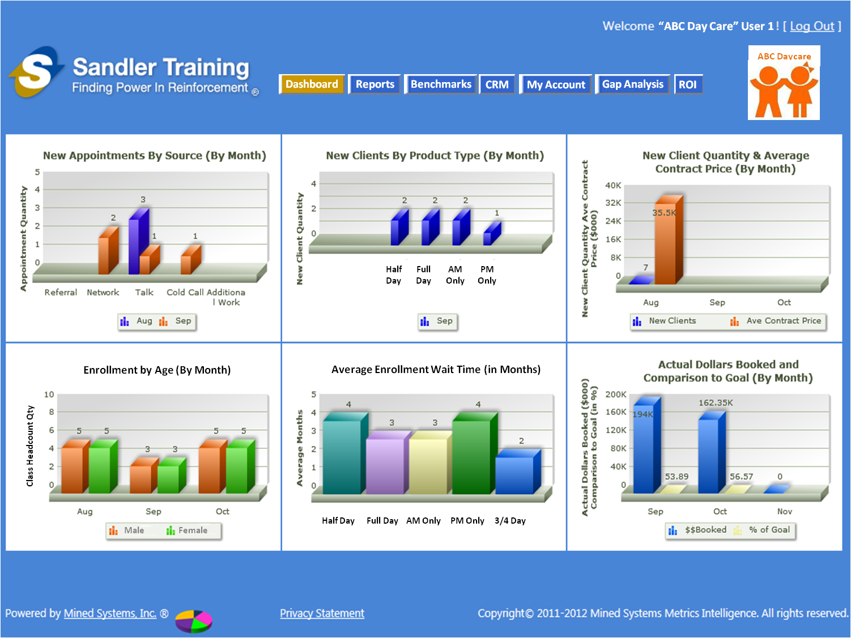

Figure 5‑1: Client Dashboard

## Client Reports

## Client Benchmark Reports

## Client CRM Functionality

## Client “My Account” Functionality

# Sending Meeting Invite from SMS

To provide enhanced e-mail capabilities from within the SMS, we need the ability to send a meeting invite to an individual or a group e-mail address